Smart Radar System using ESP32

Abstract:
This project presents the design and implementation of a Smart Radar System using ESP32, ultrasonic sensor (HC-SR04), servo motor, LCD display, buzzer, and LED. The system detects objects in real time by measuring distance using ultrasonic waves and scans the surroundings through servo-based rotation. The detected data is displayed on an LCD and alerts are generated when objects are within a predefined range. Additionally, the system supports real-time data visualization using serial communication, making it suitable for applications in security and automation.

Objectives:
- To design a real-time object detection system
- To measure distance using ultrasonic sensing
- To simulate radar scanning using servo motor
- To display output on LCD
- To provide alert mechanism using buzzer and LED
- To implement data visualization for better understanding

Components Used:
Components | Description
ESP32 | Microcontroller for processing and control
HC-SR04 | Ultrasonic sensor for distance measurement
Servo Motor | For scanning motion
16x2 I2C LCD | For displaying output
Buzzer | Foraudio alert
LED | For visual alert
Resistors | For LED and voltage division
Jumper Wires | For connections

Working Principle:
The system operates based on ultrasonic sensing. The HC-SR04 sensor transmits ultrasonic waves which reflect back upon hitting an object. The time taken for the echo to return is measured by the ESP32, which calculates the distance.
The servo motor rotates the sensor across a defined angular range (0° to 180°), enabling scanning of the environment. The calculated distance and angle are displayed on the LCD. If the distance is below a threshold value, the buzzer and LED are activated to indicate proximity.
The system also sends data via serial communication, which can be used for graphical radar visualization on a computer.

Circuit Description:
- Ultrasonic sensor TRIG pin is connected to GPIO D5
- ECHO pin is connected to GPIO D18 via voltage divider
- LCD uses I2C communication (SDA → D21, SCL → D22)
- Servo motor signal is connected to D4
- Buzzer is connected to D13
- LED is connected to D12 through a resistor
- All components share a common ground

The LCD displays real-time angle and distance data measured by the ultrasonic sensor. If the distance is less than 20 cm, the LED and buzzer turn ON as an alert; otherwise, no alert is generated.

- 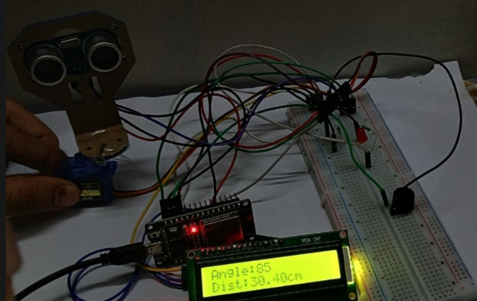
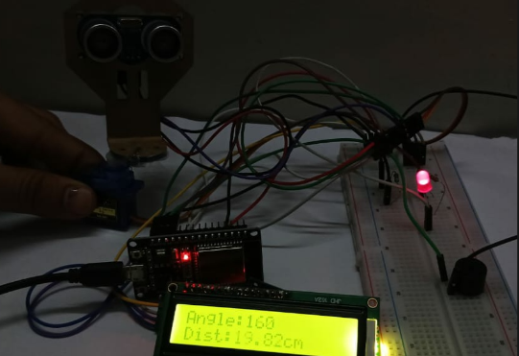

Results:
The system successfully detects objects within its range and displays the corresponding distance and angle. The servo motor enables scanning, creating a radar-like behavior. The buzzer and LED provide alerts for nearby objects. The system also supports real-time visualization through serial data output.

Applications:
- Obstacle detection systems
- Security and surveillance systems
- Smart parking systems
- Robotics and automation
- Distance monitoring systems

Advantages:
- Low cost and easy implementation
- Real-time monitoring
- Compact and efficient design
- Multi-output (visual + audio + display)
- Expandable with IoT features

Limitations:
- Limited sensing range (~400 cm)
- Accuracy affected by environmental conditions
- Servo motor power dependency
- Not suitable for long-distance detection

Future Scope:
- Integration with IoT (WiFi/Blynk)
- Mobile app-based monitoring
- Cloud data storage
- AI-based object classification
- Advanced radar visualization

Conclusion:
The Smart Radar System using ESP32 demonstrates an effective and low-cost solution for real-time object detection and visualization. The project integrates sensing, processing, and output systems efficiently. It serves as a practical example of embedded system design and can be extended for advanced automation and security applications.

Author: Madhu
B.Tech – Electronics and Communication Engineering

